**Pizza Sales SQL Queries**

1. **KPI’s**
2. **Total Revenue:**

select SUM(total_price) as Total_Revenue from pizza_sales;

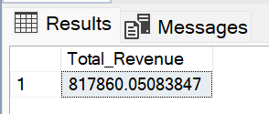

1. **Average Order Value:**

select SUM(total_price)/COUNT(distinct order_id) as Average_ord_val from pizza_sales;

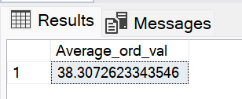

1. **Total Pizza Sold:**

select SUM(quantity) as Total_pizza from pizza_sales;

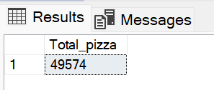

1. **Total Order Placed:**

select COUNT(distinct order_id) as Total_ord_placed from pizza_sales;

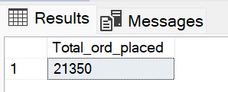

1. **Average pizza per order:**

select CAST(CAST(SUM(quantity) AS decimal(10,2)) / CAST(COUNT(distinct order_id) AS decimal(10,2)) AS decimal(10,2)) as Avg_pizza_per_ord from pizza_sales;

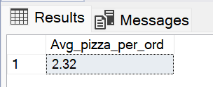

1. **Daily Trends for Total Orders:**

select DATENAME(DW, order_date) as order_day, COUNT(distinct order_id) as Total_order from pizza_sales group by DATENAME(DW, order_date);

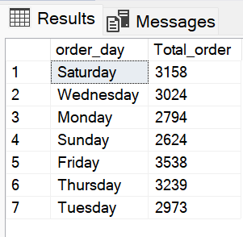

1. **Hourly Trends:**

select DATEPART(HOUR,order_time) as order_hour, COUNT(distinct order_id) as Total_order from pizza_sales group by DATEPART(HOUR,order_time) order by DATEPART(HOUR,order_time);

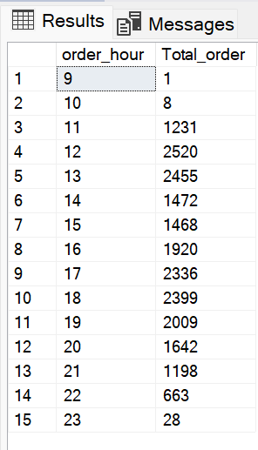

1. **Sale Percentage:**

select pizza_category , sum(total_price) as Total_sale,

CAST(sum(total_price) * 100/ (select sum(total_price) from pizza_sales) as decimal(10,2)) as Total_sale_percent from pizza_sales group by pizza_category;

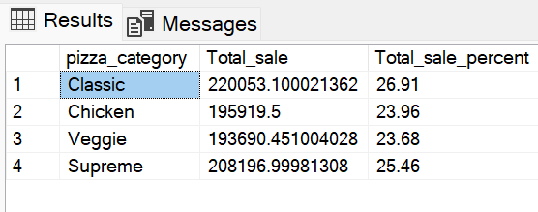

1. **Percentage of sales by pizza size:**

select pizza_size , sum(total_price) as Total_sale,

CAST(sum(total_price) * 100/ (select sum(total_price) from pizza_sales) as decimal(10,2)) as Total_sale_percent from pizza_sales group by pizza_size;

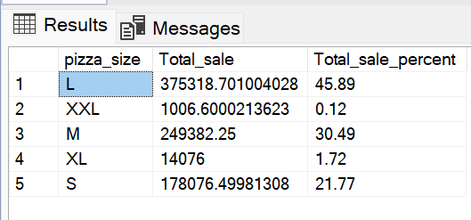

1. **Total Pizza sale by category:**

select pizza_category, sum(quantity) as Total_pizza from pizza_sales group by pizza_category;

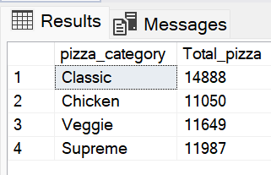

1. **Top 5 best selling Pizza:**

select top 5 pizza_name , sum(quantity) as Total_pizza_sold from pizza_sales

group by pizza_name order by sum(quantity) desc;

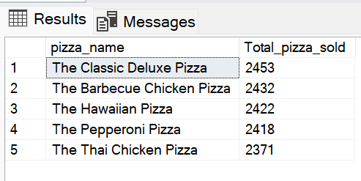

1. **Top 5 Worst seller pizza:**

select top 5 pizza_name , sum(quantity) as Total_pizza_sold from pizza_sales group by pizza_name order by sum(quantity);

